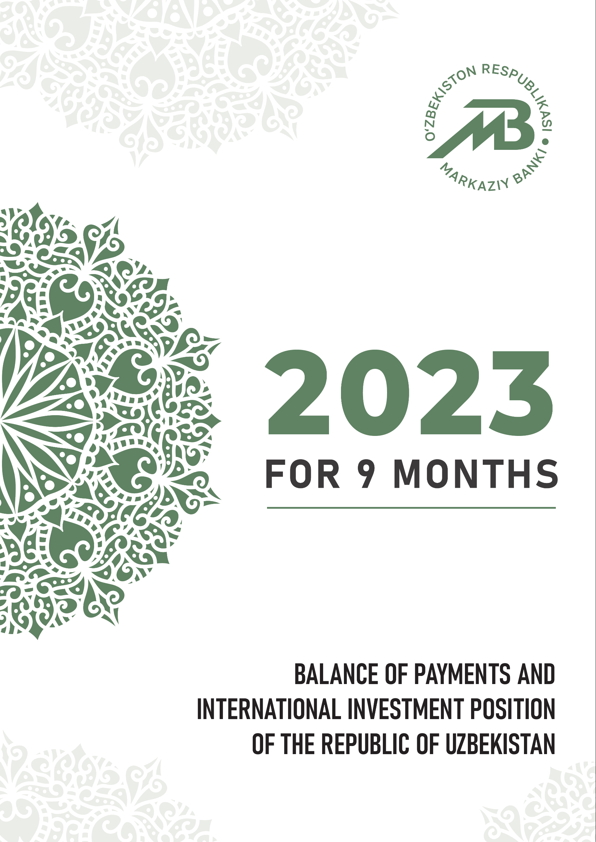

What is the publication about? |  | The publication provides information on the balance of payments and international investment position for  9 months of 2023, which was compiled in accordance with the sixth edition of the Balance of Payments and International Investment Position Manual of International Monetary Fund (BPM6, IMF, 2009).
What date are data relevant? |  | The data, presented in the publication, are relevant  as of December 28, 2023.
Where can data be found? |  | Statistical tables on the standard and analytical presentations of the balance of payments and international investment position are available on websites of  the Central Bank of Uzbekistan http://www.cbu.uz/ and  International Monetary Fund http://data.imf.org/.
Whom to contact with questions and proposals concerning the publication? |  | O. Tojiddinov  Deputy director of the department –  head of balance of payments division  (+998) 71 212-60-77 o.tojiddinov@cbu.uz  Sh. Khayitboev  Deputy head of balance of payments division  (+998) 71 212-60-42 sh.khayitboev@cbu.uz  Any questions and proposals can also be sent to e-mail address val@cbu.uz.

BRIEF REVIEW

During 9 months of 2023, current account balance of Uzbekistan’s balance of payments was formed negative and amounted to USD 4.8 bln. under the influence of several factors such as, on the one hand, recovery of tourism growth to pre-pandemic levels and reduction of supply chain disruptions, on the other hand, decrease in aggregate demand and fluctuations in exchange rates in Uzbekistan's main trading partners, increase in servicing costs of external debt, and expansion of fragmentation processes
in international trade due to geopolitical tensions.
During reporting period, due to growth in volume of imports at a higher rate than volume of exports, the negative trade balance amounted
to USD 12 bln.
The volume of exports amounted to USD 17.9 bln., and imports volume was equal to USD 29.8 bln., which increased by 13% and 17%, respectively, compared to the corresponding period of previous year.
Export of goods amounted to USD 14.1 bln. and services to USD 3.8 bln., while import of goods and services accounted for USD 24.3 bln.
and USD 5.5 bln., respectively.
The balance of primary income was negative and amounted to
USD 171.3 mln.
In 9 months of 2023, positive balance of secondary income decreased by 17% compared to the same period of last year and amounted to USD 7.3 bln.
Moreover, during reporting period, abnormal growth rate of remittance inflows in 2022 continued to return to its historical (fundamental) trends.
In 9 months of 2023, financial account balance was negative and amounted to USD 6.4 bln.
Financial assets decreased by USD 680 mln., in which operations related to other investments increased by USD 3.5 bln., while operations related to international reserve assets decreased by USD 4.2 bln.

Operations on financial liabilities amounted to USD 5.7 bln, in which direct and other investments accounted for USD 1.4 bln. and USD 4.2 bln., respectively.
During reporting period, net increase in foreign direct investment into share capital amounted to USD 855 mln. and increase in loans attracted from parent companies accounted for USD 289 mln. The net decrease in investment by enterprises operating on the basis of product sharing agreements (PSA) amounted to USD 359 mln.
Negative balance of portfolio investments in 9 months of 2023 amounted USD 129 mln. due to attraction of foreign portfolio investments to the capital of non-financial organizations, as well as, accrued interest on international bonds issued by the government of Uzbekistan, commercial banks and other enterprices and issuance of “green” Eurobonds.
The net international investment position of Uzbekistan accounted for USD 14.2 bln. as of October 1 of 2023. The volumes of assets and external liabilities of residents in the foreign currency were equal to USD 81.5 bln.
and USD 67.3 bln., respectively.

PROJECTIONS FOR 2024
Taking into account conditions in the world economy and the external sector of Uzbekistan in the context of geopolitical processes, dynamics
of changes in the conjuncture of international financial and commodity markets (distribution of foreign investments between developed and developing economies), labor and capital migration, foreign trade and logistics, as well as expectations and assessments of experts on rates of economic growth
in the main trading partners during following years, projections on balance of payments indicators of the Republic of Uzbekistan for 2024 were formed under baseline and alternative scenarios.
I. Baseline scenario
Export of goods and services. Taking into account the growth
of external demand at a moderate level (without sharp changes) in the next year, also as a result of restoring of relative advantage (competitiveness) of certain economic sectors (textiles, chemicals, food and non-precious metals industry) in the international markets and scale of financial support of these sectors by the government at a high level in the following years, the exports volume (without gold) is expected to increase by 13-15% compared to 2023, in which export of goods – by 10-12%. In turn, opportunities to enter new markets (international GSP+ system) and consistent continuation of actions
to enter the World Trade Organization are considered as motivating factors.
With increased usage of Central Asian transport corridors and high demand for Uzbekistan's transport services, large-scale reforms in the field
of tourism and information technology (IT) in Uzbekistan, export of services
is forecasted to reach USD 5.5-6 bln. in 2024.
Import of goods and services. Based on persistance of high level
of consumer demand for imported goods and machinery-equipment, vehicles and raw materials within the framework of investment programs on socio-economic development of regions (projected real GDP growth in 2024
is 5-5.7%), as well as the government's efforts to reduce fiscal deficit
(fiscal consolidation) and plans to import mineral products (oil, gas and electricity) to cover domestic consumption in 2024, the imports volume
is expected to increase by 9-11% compared to 2023, in which import of goods – by 10% and import of services – by 6%.
Primary and secondary incomes. In 2024, the primary income component contrary to historical indicators, is expected to be formed with
a negative balance (USD 274 mln.). This situation is explained, on the one hand, by the relatively low growth in short-term labor migrants’ income due
to the current geopolitical situation, on the other hand, by the increase
in servicing costs of external debt attracted at floating interest rates.
Considering shift of labor migration flows from traditional countries
to other alternative markets, scope of special programs within the framework of intergovernmental agreements directed to employ migrants
on an organizational basis and expectations of economic activity in migrant workers’ main recipient-countries as well as historical average growth rates
of transfers volume, remittances to Uzbekistan in 2024 are expected
to increase by 12-14% compared to 2023, while the secondary income component will be formed with a positive balance.
Financial account. In 2024, the current account deficit is expected to be financed mainly by the net inflow of foreign direct investments (to be at the level of 2022 due to expected investments in energy, mining, mechanical engineering, chemical industry, banking and finance and other sectors), portfolio investments (issuance of new Eurobonds in international financial markets) and external debt.

II. Alternative scenario
Under alternative scenario, the formation of balance of payments indicators might be influenced by the following factors:
1. Lower than expected economic growth in Uzbekistan's main trading partners as a consequence of expansion of geo-economic fragmentation processes and increasing vulnerabilities in certain sectors of the global economy (for example, the real estate crisis in China);
2. Decrease in external aggregate demand for Uzbekistan's main export non-commodity goods and world prices of precious metals;
3. Increase in the cost of servicing external debt as a result of maintaining tighter global monetary conditions;
4. Decline in the volume of remittances resulted from high fluctuations in FX rates of the main sender countries due to aggravation of geopolitical situation, decrease in prices of energy products and strengthening
of sanctions;
5. Decrease in demand for imported goods as a result of a certain slowdown in economic activity in Uzbekistan (according to the alternative scenario, projected real GDP growth in 2024 is 3-4%) and an optimization
in population’s real income.

Addenda 1. Balance of payments for the 9 months of 2021-2023
(analytic presentation)
(mln. USD)
Indicators | 9 months  of 2021 | 9 months  of 2022 | 9 months  of 2023
A. Current account balance | -5 208,2 | 197,4 | -4 797,0
Goods, credit (exports) | 8 509,0 | 12 453,2 | 14 099,4
Goods, debit (imports) | 16 499,4 | 20 093,9 | 24 293,3
Services, credit (exports) | 1 680,8 | 3 432,5 | 3 789,6
Services, debit (imports) | 3 544,9 | 5 324,1 | 5 553,2
Balance on goods and services | -9 854,5 | -9 532,3 | -11 957,6
Primary income, credit | 1 815,1 | 3 193,5 | 2 824,0
Primary income, debit | 1 550,6 | 2 346,3 | 2 995,3
Balance on goods, services, and primary income | -9 589,9 | -8 685,0 | -12 128,9
Secondary income, credit | 4 827,8 | 9 531,7 | 7 867,8
Secondary income, debit | 446,0 | 649,3 | 535,9
B. Capital account (excluding reserve assets) | 4,0 | 11,6 | 7,9
Capital account, credit | 4,0 | 11,6 | 7,9
Capital account, debit | 0,0 | 0,0 | 0,0
Balance on capital account and current account | -5 204,1 | 208,9 | -4 789,1
C. Financial account | -4 466,2 | 1 231,5 | -2 212,6
Direct investment: assets | 1,9 | 3,3 | 11,1
Direct investment: liabilities | 1 876,7 | 1 706,7 | 1 351,8
Portfolio investment: assets | 0,0 | 0,0 | 0,2
Equity and investment fund shares | 0,0 | 0,0 | 0,2
Debt securities | 0,0 | 0,0 | 0,0
Portfolio investment: liabilities | 1 289,8 | 29,5 | 129,3
Equity and investment fund shares | 10,8 | 17,2 | 16,5
Debt securities | 1 279,0 | 12,3 | 112,8
Financial derivatives (other than reserves) | 9,7 | 8,7 | 1,6
Financial derivatives: assets | 0,0 | 0,0 | 0,0
Financial derivatives: liabilities | -9,7 | -8,7 | -1,6
Other investment: assets | 2 860,2 | 9 857,2 | 3 504,0
Other equity instruments | 0,6 | 0,4 | 0,4
Debt instruments | 2 859,6 | 9 856,8 | 3 503,6
Central bank | 0,0 | 0,0 | 0,0
Deposit-taking corporations (except the central bank) | -80,3 | 3 391,3 | -892,2
General government | -14,2 | -15,3 | -511,3
Other sectors | 2 954,0 | 6 480,8 | 4 907,1
Other financial corporations | 0,0 | 0,0 | 0,0
Nonfinancial corporations, households, and NPISHs | 2 954,0 | 6 480,8 | 4 907,1
Other investment: liabilities | 4 171,3 | 6 901,6 | 4 248,4
Other equity | 0,0 | 0,0 | 0,0
Debt instruments | 4 171,3 | 6 901,6 | 4 248,4
Central bank | 0,0 | 0,0 | 0,0
Deposit-taking corporations (except the entral bank) | 839,8 | 3 730,1 | 876,2
General government | 574,8 | 671,4 | 895,4
Other sectors | 2 756,8 | 2 500,2 | 2 476,8
Other financial corporations | 766,0 | 24,0 | 23,3
Nonfinancial corporations, households, and PISHs | 1 990,8 | 2 476,2 | 2 453,5
D. Net Errors and Omissions | -860,9 | -404,3 | -1 619,1
E. Overall Balance | 1 598,9 | 1 426,9 | 4 195,6
F. Reserves and Related Items | -1 598,9 | -1 426,9 | -4 195,6
Reserve assets | -1 599,0 | -1 426,2 | -4 195,3
Net credits from the IMF (other than reserves) | 0,0 | 0,6 | 0,3
Exceptional financing | 0,0 | 0,0 | 0,0
This statistic report uses analytic presentation, described in the 6th edition of the Balance of Payments Manual (BPM6).

Addenda 2. International investment position for 2021-2022
and the 9 months of 2023
(mln. USD)
Indicators | 01.01.2022 | 01.01.2023 | 01.10.2023
Assets | 70 404,0 | 82 293,7 | 81 535,9
Direct investments | 197,7 | 202,0 | 208,2
Equity instruments and investment fund shares | 29,8 | 31,6 | 36,0
Investments of direct investor in direct investment enterprises | 29,8 | 31,6 | 36,0
Investments of direct investment enterprises in direct investor (reverse investment) | 0,0 | 0,0 | 0,0
Investments between fellow enterprises | 0,0 | 0,0 | 0,0
Debt instruments | 167,9 | 170,3 | 172,2
Investments of direct investor in direct investment enterprises | 2,5 | 2,5 | 2,5
Investments of direct investment enterprises in direct investor (reverse investment) | 0,0 | 0,0 | 0,0
Investments between fellow enterprises | 165,4 | 167,9 | 169,7
Portfolio investments | 2,5 | 2,5 | 2,6
Equity instruments and investment fund shares | 2,5 | 2,5 | 2,6
Central Bank | 0,0 | 0,0 | 0,0
Deposit enterprises, excluding the Central Bank | 1,1 | 1,1 | 1,1
General government | 0,0 | 0,0 | 0,0
Other sectors | 1,4 | 1,4 | 1,5
Other financial institutions | 0,0 | 0,0 | 0,0
Debt securities | 0,0 | 0,0 | 0,0
Central Bank | 0,0 | 0,0 | 0,0
Deposit enterprises, excluding the Central Bank | 0,0 | 0,0 | 0,0
General government | 0,0 | 0,0 | 0,0
Other sectors | 0,0 | 0,0 | 0,0
Other financial institutions | 0,0 | 0,0 | 0,0
Financial derivatives (other than reserves) and employee stock options | 0,0 | 0,0 | 0,0
Other investments | 35 064,6 | 46 321,7 | 50 285,8
Other equity instruments | 1,2 | 1,6 | 2,0
Debt instruments | 35 063,4 | 46 320,1 | 50 283,8
Central Bank | 0,0 | 0,0 | 0,0
Deposit enterprises, excluding the Central Bank | 2 935,4 | 4 556,9 | 3 612,9
General government | 3,3 | 3,7 | 7,4
Other sectors | 32 124,7 | 41 759,5 | 46 663,5
Other financial institutions | 0,0 | 0,0 | 0,0
Reserve assets | 35 139,2 | 35 767,5 | 31 039,3
Monetary gold | 20 949,7 | 23 064,8 | 23 095,5
Reserve position in IMF | 0,0 | 0,0 | 0,0
Other reserve assets | 14 189,5 | 12 702,7 | 7 943,8
Liabilities | 53 586,0 | 63 407,2 | 67 351,6
Direct investments | 11 594,1 | 13 652,4 | 13 967,5
Equity instruments and investment fund shares | 10 054,1 | 11 361,2 | 11 461,7
Investments of direct investor in direct investment enterprises | 10 054,1 | 11 361,2 | 11 461,7
Investments of direct investment enterprises in direct investor (reverse investment) | 0,0 | 0,0 | 0,0
Investments between fellow enterprises | 0,0 | 0,0 | 0,0
Debt instruments | 1 540,0 | 2 291,2 | 2 505,8
Investments of direct investor in direct investment enterprises | 1 376,7 | 2 024,0 | 2 302,8
Investments of direct investment enterprises in direct investor (reverse investment) | 0,0 | 0,0 | 0,0
Investments between fellow enterprises | 163,3 | 267,2 | 202,9
Portfolio investments | 4 720,4 | 4 192,1 | 4 266,1
Equity instruments and investment fund shares | 83,5 | 105,8 | 117,7
Central Bank | 0,0 | 0,0 | 0,0
Deposit enterprises, excluding the Central Bank | 37,1 | 48,4 | 53,6
General government | 0,0 | 0,0 | 0,0
Other sectors | 46,4 | 57,4 | 64,1
Other financial institutions | 0,9 | 1,3 | 1,5
Debt securities | 4 636,9 | 4 086,3 | 4 148,4
Central Bank | 0,0 | 0,0 | 0,0
Deposit enterprises, excluding the Central Bank | 993,2 | 893,9 | 1 028,3
General government | 2 669,2 | 2 375,0 | 2 272,7
Other sectors | 974,5 | 817,3 | 847,5
Other financial institutions | 0,0 | 0,0 | 0,0
Financial derivatives (other than reserves) and employee stock options | 11,5 | 2,0 | 0,2
Other investments | 37 259,9 | 45 560,8 | 49 117,8
Other equity instruments | 0,0 | 0,0 | 0,0
Other debt instruments | 37 259,9 | 45 560,8 | 49 117,8
Central Bank | 0,0 | 0,0 | 0,0
Deposit enterprises, excluding the Central Bank | 6 766,0 | 10 441,4 | 11 041,2
General government | 15 290,6 | 18 007,8 | 18 673,8
Other sectors | 15 203,2 | 17 111,7 | 19 402,8
Other financial institutions | 72,2 | 105,0 | 118,3
Net international investment position | 16 818,1 | 18 886,5 | 14 184,3

Main directions of monetary policy for 2024 and 2025-2026. Publication of the Central Bank of the Republic of Uzbekistan, 2023.
Main directions of monetary policy for 2024 and 2025-2026. Publication of the Central Bank of the Republic of Uzbekistan, 2023.

